## AI ASSISTED CODING

## TASK 2:

>> Use copilot to generate a is_prime() python function.

**prompt:**

Write a python code to check whether a number is prime or not.

**Expected output:**

Function to check primality with correct logic.

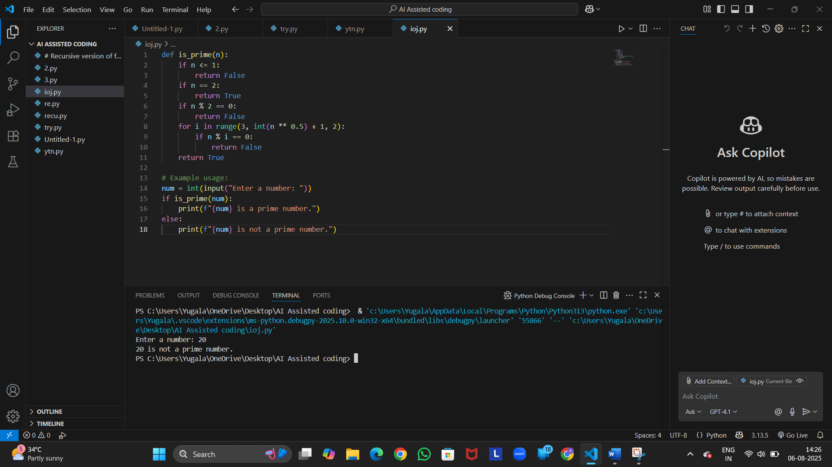

**Observation:**

A prime number is a number greater than 1 that has no positive divisors other than 1 and itself.

* **Functionality**: Returns True for prime numbers and False otherwise.
* **Suitable for checking primality of large numbers due to reduced iterations.**

## TASK 3:

>>Write a comment like # function to reverse a string and use copilot to generate the function.

**Prompt:**

>>Write a python code for comment like # function to reverse a string and use function.

**Expected output:**

>>Auto-completed reverse function.

**Observation:**

* **Logic: Uses Python slicing [::-1] to reverse the string efficiently.**
* **Simplicity: One-liner function; concise and readable.**
* **Functionality: Works for letters, numbers, symbols, and even empty strings.**

## TASK 4:

>>Generate both recursive and iterative version of a factorial using comments.

**Prompt:**

>>Write a python to generate both recursive and iterative version of a factorial using comments.

**Expected output:**

>>Two working factorial implementations.

**Observation:**

* **Recursive Version:**
* **Elegant and mirrors the mathematical definition.**
* **May cause stack overflow for large n due to deep recursion.**
* **Time complexity: O(n); Space complexity: O(n) (due to call stack).**
* **Iterative Version:**
* **More memory-efficient and avoids recursion limits.**
* **Preferred for large values of n.**
* **Time complexity: O(n); Space complexity: O(1).**
* **Both Implementations:**
* **Correctly handle base cases (0! = 1, 1! = 1).**
* **Produce identical results for valid non-negative integers.**

## TASK 5:

>>Use copilot to find the largest number in a list. Assess code quality and efficiency.

**Prompt:**

>> Write a python code to find the largest number in a list and assess code quality and efficiency.

**Expected output:**

>> A valid function with your review.

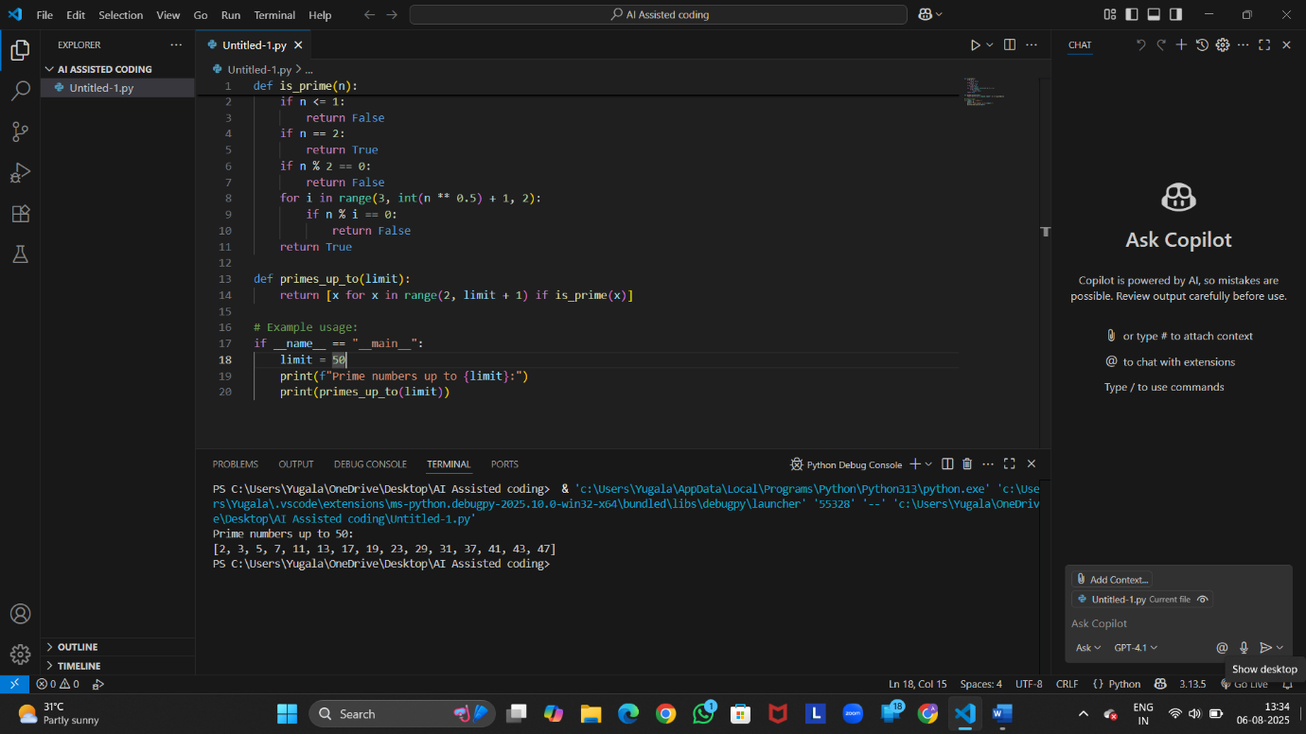

**Observation:**

* **Correctness: Accurately finds the largest number by comparing each element.**
* **Edge Case Handling: Returns None for an empty list, avoiding errors.**
* **Efficiency:**
* **Time complexity: O(n) — linear scan through the list.**
* **Space complexity: O(1) — uses constant extra space.**
* **Code Quality:**
* **Clear variable naming (largest, numbers).**